Our Immigrant Ancestors

Captain John Outlaw came to Norfolk County, Virginia about 1665-1667 and appears in the records of Norfolk County and North Carolina 1668-1672. Our immigrant ancestor, EDWARD OUTLAW, was Captain John’s much younger brother, a minor at the time. In studying the escapades of Captain John, a turbulent character, it seems almost like reading about my own father John. Both marched to the beat of their own drummer and were disdainful of public opinion and authority. In the following account, the italicized print is quoted from Historic Southern Families written by genealogical researcher Benjamin C. Holtzclaw.

“The first appearance of John Outlaw in the records of Norfolk County was on May 8, 1668, when a difference between John Outlaw and Edward Wesray, was referred to the next Court (Book “E”, Part II, Orders, p. 22a). On the same date John Outlaw, Edward Outlaw, and Thomas fforkin were convicted of unlawfully killing a steer, and they were ordered to pay a fine of 2000 pounds of tobacco, ½ to William Memocks, Thomas Smith, Edward Shoulder, and Thomas Ward, presumably the owners of the beast, and ½ to the County (same reference). John Outlaw seems to have borne the burden of the fine, indicating that his brother Edward was under age, and perhaps Thomas fforkin, too. John Outlaw got into trouble again in August, 1668, when he had a brawl with a constable, William Dafnell, at the funeral of Robert Spring’s first wife, Isabel. On Feb. 15, 1668/69, Capt. John Outlaw was among those ordered to assist in clearing the roads (ibid, p. 29a), and on the same date (p. 30) William Dafnell arrested John Outlaw in an action for debt, and Outlaw not appearing, his security was ordered to pay. Book “E”, p. 48, gives the depositions of Mary ffanshaw and Robert Tucker regarding the trouble with Dafnell in August, 1668. Mary ffanshaw, aged about 21, deposed on Feb. 15, 1668/9 that “being at the house of Robert Spring at the funeral of his wife there was a difference between John Outlaw & John Johnson & (they) fell out, & they called for the constable to Command the peace by him the said constable, Wm. Davnell. With that Jno. Outlaw came to the door and said he would be revenged upon Wm. Davnell and struck the said Davnell two or three blows more and called him rogue and Cuckold”. Robert Tucker, aged about 23, deposed that “being at the house of Robert Spring in Augt. last past there was some difference between Capt. John Outlaw and John Johnson and Edward Outlaw, and Edward Outlaw (is this a lapus styli for John?) Said unto his Brother pray lett me alone for I will be revenged of that whore and rogue, meaning William Dafnell and his wife, and running unto the door said , you say I owe you a hogshd. of Tobacco. I will pay you with a pox and struck him two or three blowes on the head and she fell into a swound and William Dafnell said, what is the matter with you, Capt. Outlaw, I have charged the peace before you and I know not what to doe with you. With that John Outlaw struck Dafnell two several times”. (Note, that William Dafnell later became Edward Outlaw’s father-in-law.)

In connection with this case, on March 31, 1669 John Outlaw of the Western Branch of Elizabeth River appointed Thomas Gilbert his attorney in two suits “depending between me and William Davenall”(Bk. “E”, p. 46). More trouble was coming, for on April 21, 1669 Enoch Tarte got an attachment against the estate of John Outlaw (Bk.“E”, Part II, Orders, p. 33), and about that time John seems to have moved to North Carolina. On Nov. 17, 1669 Thomas Boures was fined in Norfolk County for not appearing in the suit of Enoch Tarte vs. John Outlaw (ibid, p. 40a); and on the following day, Nov. 18, the Court ordered that Enoch Tarte be paid 2040 pounds of tobacco out of John Outlaw’s estate, it being stated that in April last John Outlaw was ordered to pay William Dafnell, Constable of the Western Branch, 1000 pounds of tobacco, and “Robert Boures, security for Outlaw, is to pay it, Outlaw having absented himself” (ibid, p. 42). This is the last mention of John Outlaw in the Norfolk County records until April 16, 1672, when it was ordered that Enoch Tarte was to have 2040 pounds of tobacco, granted him in Nov. 1669, out of the estate of John Outlaw (ibid, p. 85). In the meantime, John Outlaw was continuing his inauspicious career in North Carolina. At the General Court there, Sept. 27, 1670, he sued Samuel Pricklove, and at the same Court was sued by Capt. Cath Cone (Hathaway, “N.C. Hist. & Gen. Register”, Vol. I, p. 135). At the same Court Laurence Gunfallis sued John Outlaw (ibid, p. 136), and it is stated “Laurence Gunfallis obtained an order against Capt. Jo. Outlaw in May Court, 1670 for a bote of 14 foot and whereas said Outlaw departed from his house and there can be no bote had, Mr. Herman Smewin and Abraham Kimberley were sworn in Court to appraise ye worth of ye said bot who vallowed said bote to be worth 750 pounds of tobacco and cask, and cost of sale, wherefore it is ordered ye said Gunfallis satisfy his debt out of ye said Outlaw’s estate where it can be found”. (Bk. “O”, pp. 10-11). The last mention of John Outlaw in North Carolina was in 1672 (as in Norfolk Co., Va.) when he was sued by Samuel Davis (Hathaway, op. Cit., Vol. I, p. 140). What became of him is uncertain.”

Outlaw Genealogy written by Abner Henry Outlaw does not offer any additional records concerning Captain John Outlaw but states “ Captain John was a boat captain and a boat builder and probably a tobacco farmer as he seemed able to pay some fairly steep court fines in tobacco poundage. He was never married as far as we know. His parentage, back in England’s County Norfolk, is unknown as are siblings, if any, other than Edward... It is believed that he returned to England around 1670 and died there as there are no further records of him in Norfolk County, Va. or the Albemarle counties, N. C.”

In the preceding account written by Benjamin Holtzclaw for Historic Southern Families he omitted another action at the same General Court held 27 September 1670 at the house of Samuel Davis in the county of Albemarle of the Province of North Carolina (North Carolina Historical and Genealogical Register, January 1900, Volume 1, No. I, page 136). The Honorable Peter Carteret , Governor and Commander-in-Chief was present and probably presided over the court. In the omission John Barrows petitioned the court to have an attachment against the estate of John Outlaw; there appears to be due to him 200 lbs. of tobacco.

This speculation about Captain John being a tobacco farmer in Outlaw Genealogy may be true, but it seems to ignore the most likely source of Captain John’s wealth in tobacco, that is, the result of profitable trading along the eastern coastline and possibly boat/ship building on the Elizabeth River. What would be more natural, viewing his proclivity for the sea than to engage in trade up and down the eastern coastline? The following case found in the Maryland State Archives of the Provincial Court Proceedings appears to substantiate this theory. George Attkins plaintiff sued the defendant James Veitch in an account of debt for 12,000 pounds of tobacco. The defendant failed to appear, alleging to the court that he was too sick to travel so far, and he was ordered to make an appearance before the next Provincial Court. George Attkins was represented by Morecroft and James Veitch was represented by Daniel Jenifer at the 1668 court. ...the said James by Daniel Jenifer his Attorny Cometh and defendeth the force and injury ...he saith that at the time and place in the declaration mentioned the said James was not bound to pay to JOHN OUTLAW or the said George the said summe as in the said declaration....” For want of sufficient testimony to prove the plaintiff’s declaration, judgment was awarded against him. Since the court date of 1668 is about the same time that Captain John appears in Virginia court records and Veitch’s debt took some time to occur beforehand, it may indicate that John and Edward arrived first in Maryland when they came to the New World. If he was actively trading up and down the coastline, this could account for him not making the appearances in court in the Norfolk and North Carolina records.

On 20 April 1682 Edward and Dennis Aishley obtained 556 acres of land in Lower Norfolk County at the head of the Western Branch of the Elizabeth River and 250 acres of this patent was granted for transporting 5 persons into the Virginia Colony. Edward listed himself twice on the patent which indicates that he entered the colony two times, as might be expected of an active seaman. Edward obtained another 50 acre credit for Robert Calderwood’s transportation, evidently another seaman, as Calderwood was also listed on land patents to Christopher Bustian (3 times) and Lucy Keeling (1 time) for 50 acre credits. It should also be noted that Dennis Aishley is the name on the land patent, not Dennis Ashley as listed in Historical Southern Families on page 3. Although this may seem a trivial point, different surname spellings help to separate families of similar surnames.

Although Captain John returned to England several times he did not return to live there. A Captain John Outlaw appears in several records other than those of Virginia and North Carolina. Considering the population density of the New World settlements, the rarity of the Outlaw surname coupled with the Christian name of John, and the same vocation of a ship’s captain, the odds are overwhelming that this John is the same as our ancestor Edward’s brother. Robert Evans Page emailed an inquiry to the Internet mail list Gloucester-L@rootsweb.com seeking information on a Captain John Outlaw. He stated “I have just discovered that I am descended from an English sea captain, John Outlaw whom I originally found at the end of one of my French Canadian links under the name Jean Outelas/Houtelas. In 1665, he captained a ship in the fleet of Edward Morgan in his expedition against the Dutch in the Antilles. Later in the 1680s Capt. Outlaw commanded ships for and against the Hudson Bay Company. He ended his life sailing for the French out of Port Royal, Nova Scotia.”

In the engagement against the Dutch in 1665, Captain John Outlaw commanded the ship The Olive Branch which was outfitted with six canon.

Some of the information available about this Canadian John Outlaw in the online biographies and family genealogies is sometimes contradictory. The following is quoted from Volume I of The Dictionary of Canadian Biography Online written by Professor G. E. Thorman. HBC is the abbreviation for Hudson Bay Company. My comments including data from other sources are printed in red.

“OUTLAW, JOHN (Outlan or Outlas, Jean), ‘Marriner & Shipwright’ of Limehouse, England; d. c. 1696–97

He served as mate on the Bachelor’s Delight, commanded by Benjamin Gillam who sailed from New England on 21 June 1682 and founded a post 26 miles up the Nelson River. [June 21st, 1682 – “Ben Gillam, son of Capt. Gillam of the “Prince Rupert” with John Outlaw from Boston at the expense of the Company of the North (French) landed at Port Gibson in an attempt to divide the spoil with the Hudson’s Bay Co.”] Subsequently Radisson and Chouart Des Groseilliers, and John Bridgar established posts for the French and HBC respectively. Radisson captured the two rival posts in 1683. Some of the English prisoners were put on the unseaworthy Sainte-Anne, and Outlaw navigated it to James Bay, whence he returned to England in the HBC ship, Diligence (Capt. Nehemiah Walker).

Despite Outlaw’s being an interloper (i.e. a poacher with Gillam) who had infringed their patent the HBC hired him for their 1684 voyage. He was given command of the Lucy and sailing with the Happy Return made a successful voyage to and from Port Nelson. Radisson, his captor of the year before and now in English pay, was a passenger on the Happy Return, and Henry Kelsey, on his first voyage to the Bay, was aboard the Lucy [Professor K. G. Davies of the University of Bristol, England writes that Kelsey, explorer, mariner and overseas governor of the HBC, was apprenticed to the HBC for a term of four years on 15 March 1684 and sailed with Captain John Outlaw onboard the Lucy on 6 May 1584 to the Hudson Bay.]

Outlaw commanded the Success in 1685 and on the voyage out encountered two French ships from Port Nelson under Claude de Bermen* de La Martinière with the captured English vessel Perpetuana Merchant. He was unable either to seize the French ships or to release their prize. Homeward bound from Charlton Island the Success was wrecked by ice; passengers and crew made their way to Charles Fort on Rupert River. Outlaw spent the winter at Moose. In the spring of 1686 Pierre de Troyes captured Moose (which the French called Saint-Louis) and at Rupert River captured both the post and the HBC ship, Craven. . [The Frenchman Chevalier de Pierre Troyes divided his command into two groups, one to attack Fort Charles and the other to seize the ship. To Lemoyne D’Iberville he entrusted the naval part of the program, gave him a boarding party, and left him to his own devices. Pleased at the confidence shown in him, the young man placed his men in two boats and started under cover of darkness for what was to be another surprise attack. Climbing over the Craven’s side, the Canadians found the sentinel sound asleep. They promptly secured this valiant watchdog, then stamping on the watch below – it was evidently a point of etiquette to waken the enemy before attacking them – they drove the sleepy sailors back with their swords as they swarmed up the companionway. A dose of lead fired into the main saloon nipped an incipient rally in the bud, and the crew of fifteen half-clad men meekly surrendered, together with Governor Bridgar, newly appointed commander of the Hudson Bay posts, and Captain John Outlaw.] Outlaw piloted the Craven to Moose where de Troyes loaded it with cannon before proceeding to capture Albany (Sainte-Anne). Outlaw and many of the English prisoners were sent in the Colleton to winter at Port Nelson and Severn, subsequently returning to England in 1687.

Outlaw and his crew were refused their wages for alleged negligence in losing the Success. Therefore in 1688, the disgruntled Outlaw joined John Abraham in an interloping expedition on the Mary but she was wrecked by ice in Hudson Strait. The crew were happily rescued by the HBC ship Churchill (Capt. William Bond) which, with the Yonge, was taking a new governor, Marsh, and men to Albany to establish a post near the former English fort captured by the French in 1686. The new post was established but Pierre Le Moyne d’Iberville captured it during the winter and Outlaw was taken prisoner by the French for the third time. He accepted his destiny and deserted to the French either then or shortly afterwards In 1690 the HBC warned its servants that Outlaw was a potential interloper. [The Committee emphasized gratitude as an important part of their relationship with their servants. In 1690, the Committee referred to Captain John Ford (who was captured by the French in 1689 and defected to their service) and servants- turned interlopers John Abraham and Captain John Outlaw as “ungrateful perfidious men, who have eate of our Bread & turne Renegadoes, towards us afterwards.]

At Quebec in 1692 Outlaw married Françoise Denis (his first wife was Mary Saille of London) and had three children by her. He commanded a royal frigate La Boufonne, which left Quebec on a privateering expedition on 9 June 1696 (n.s.). He may have been the “sieur Outlas” to whom some land in Acadia was granted in 1697 and the “Outelas” forbidden by Governor Joseph Robinau de Villebon in August 1697 to go off on a cruise without further instructions. Outlaw died before July 1698, when his wife was remarried.
G. E. Thorman

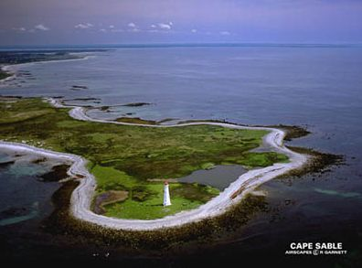

An entry concerning Captain John Outlaw was found in the 1696 miscellaneous judicial papers in the Quebec Province Archives.. It concerned the capture of two English ships at the Sable Cape in Nova Scotia by the brigantine Frontenac under the command of Jean Outlas (John Outlaw). The two English ships were the sloop Brothers Adventurers commanded by Joseph Turner with Hugh Putnam aboard, both of Massachusetts Bay and the brigantine Adventure under the command of James Philbricke of New Hampshire.

In a letter dated September 13, 1697, William Stroughton of Maryland wrote that this coast was lately infested by a small French Privateer from Canada, one Outlaw, an English Renegade Commander. I do not hear of any mischief done by the same except the taking of five open Sloops, three of which he burnt and carried the other two away. He landed the prisoners on shore which he had some time before taken in fishing vessels at Cape Sables

Canadian records state that Captain John Outlaw was born in Limehouse, England. Limehouse is located down the River Thames, two or three miles from the Tower of London. In the writer’s research, other mariners were noted as coming from Limehouse, and Henry Hudson who established the Hudson Bay Company sailed out of the Thames bound for Canada. John Thompson finished his apprenticeship years around 1640 as a mariner presumably at Limehouse where he lived and subsequently made several trips to America. Another mariner, Robert Juet, from Limehouse, England served under Henry Hudson in as least four of his trips to America, at least two of which he served as first mate. George Durant was the Chief Mate of the Carolina at her August 1677 launching at Limehouse, England and on her trip to Albemarle County, North Carolina between October 1677 and December 1, 1677 and on her return to England from May to July 1678.

The launching of the Carolina in August 1677 at Limehouse, England offers further evidence that Captain John and his brother Edward were from Limehouse. As a ship builder, Captain John most likely learned his trade at the Limehouse shipyards, and Edward, a minor when they arrived in Virginia, learned the trade from him.

An appeal and complaint of Nullity was brought by Ludovic Connor of Virginia, a merchant and owner of the Salamander sloop, of which John Ralph was master, against John Seymor, Governor of Maryland, and John Rously, naval officer for the District of Pattoxon, and Thomas Smith, Procurator General for the Crown, over seizure of certain goods aboard his ship (High Court of Admiralty; Hampton, Virginia, Instance and Prize Courts: Book of Acts 1709/10-1712/3). In the court case the following details were brought out by various depositions. The Salamander, John Ralph, master, was built for the coastal trade and for no other service in the Elizabeth River, Virginia about 1707 for Lewis Connor, a merchant. In April 1708 molasses and sugar were laden on the ship in the James River. Given a permit to sail to the Potomac, no further security was needed for such a trip. The sloop was seized in the Potuxon River in Maryland. EDWARD OUTLAW, ship’s carpenter and builder of the Salamander, filed a two page deposition on July 30, 1711 in the case.

It’s interesting to note that even as far back as 1708, Maryland and Virginia were bickering over control of the commerce on the Potomac River, disagreements which continued into more modern times. Unlike most rivers where the center of the river forms the boundary between states, the low tidewater mark on Virginia’s side of the Potomac is Maryland’s state boundary. This boundary allowed the operation of slot machines in Colonial Beach in the 1950s although gambling was illegal in Virginia. The gambling casinos in the Potomac River were legally in Charles County, Maryland, as there was an air gap between their piers and the Virginia shore. Although few people in the writer’s area currently make their living as watermen, in the 1960s the writer counted over 120 oyster boats one afternoon in the Potomac opposite the town’s beach. Competition over harvesting the crabs and oysters led to “oyster wars” in the past between Maryland and Virginia watermen.

The Lucy commanded by Captain John Outlaw for the Hudson Bay Company was a 120 ton vessel. Tonnage is a measure of the size or cargo capacity of a ship. The term derives from the taxation paid on tuns of wine, and was later used in reference to the weight of a ship’s cargo. To get some idea of the size of this ship, the Susan Constant, was also a 120 ton vessel and was the largest of the three ships of the Virginia Company which in the 1607 voyage that resulted in the founding of the first permanent English settlement in North America, Jamestown, in the new Colony of Virginia. On that voyage, she carried 71 colonists, all male. Photographs of the replica of the 116 feet long Susan Constant anchored at Jamestown are attached to this report.

The fur trade of the Hudson Bay Company was an extremely lucrative enterprise with dividends of 50 per cent being paid for the years 1683 and 1684 despite the interception of furs by the French overlanders. The Company had a fleet of seven vessels, each carrying from twelve to twenty men plying to and from the bay. Three of the ships – Happy Return, Captain Bond; Owner’s Good Will, Captain Lucas, and Success, Captain Outlaw – were yearly chartered from Sir Stephen Evance, a rich goldsmith, who had become a heavy shareholder in the Company, The other ships were The Diligence, Captain Walker, The Perpetuana Merchant, Captain Hume, the sloop Adventure, Captain Geyer and one frigate.

From the accounts of the French adventurer Peter Esprit Radisson, who defected to the English at the mouth of the river at Port Nelson “… That pleasure was followed soon followed by another; for I saw in this same place 2 ships, of which one had the glorious flag of His Majesty hoisted upon his main mast, for I recognized to be the one that was commanded by Captain Outlaw when the one in which I was passed had been separated from 2 others. This ship floating the Royal Standard of England was the Alert , commanded by Captain Outlaw, having brought out the Company’s new Governor, William Phipps, the previous season.

. Unfortunately, the biography of Captain John Outlaw written by G. E. Thorman, Vice-Principal and Head, Guidance Department, Teacher of English and History, St. Thomas Collegiate, St. Thomas, Ontario, does not identify the three children of this marriage. Robert Evans Page in his emailed Internet inquiry stated that he was a descendant of Captain John Outlaw’s son Joseph (1697-1777). Joseph’s daughter, Marie Francoise Houtelas (1730-?) migrated southward into the Illinois country where she married Joseph Antoine Drouet de Richarville in Kaskaskia (Illinois) in 1756. Joeph Antoine was the last French commander of Fort Vicennes (Indiana) until the fort was turned over to the British at the conclusion of the 7-year war.

Several online genealogies list a Outelas/Outlaw/Houtelas as an Canadian ancestor, but differ widely in the details surrounding their life as might be expected from the scarcity of good hard factual data. These genealogies are the Huppe/Mailhot/Boisjolie; Rainville and Associated Families; the Family Chartrand; the Premiere Generation; the Famille de Regis St. Pierre; and the Descendants of Jean Boucher.

In sifting through the often conflicting data of these genealogies, the following summation is deemed the most likely account of our uncle of long ago.
A Genealogy of French North America Regional Index of immigrants by Denis Beauregard from Limehouse, Middlesex, England lists “Outlaw, John & Jefferis, Elizabeth (before 1676) as an entry with their destination as being Acadie, Quebec. Both Captain John and Elizabeth apparently were born around 1635 in Limehouse and were married there around 1660, so Captain John left a wife at home in England when he and Edward sailed across the ocean to Virginia.

The three children of Jean Outelas and Marie-Francoise Denis were: (1) Jean Outelas, born 30 September 1694, died 28 January 1695, (2) Jean-Philippe Outelas, born 12 April 1696, (3) Joseph Outelas, born 10 July 1697. Marie-Francoise, born on November 14, 1666, married Jean Outelas in 1692, and remarried in 1698, so Jean must have been died between 1696 and 1698, probably in Acadia

The Descendants of Jean Boucher lists Marie Ann Boucher de Montbrun as one of the many children of Jean Boucher de Montbrun and Francoise Claire Clarets. Marie Ann was born 2 June 1708 in Boucherville, Montreal, Quebec, died 26 January 1736/1737 in Boucherville, Montreal, Quebec. She married Joseph Outlas on 25 July 1729 in Montreal, Quebec. After her death Joseph married Catherine Le Gardeur de Croisille (b. 9 May 1714) on 27 October 1744 in Quebec. A list of the 1700’s Kaskaskia, Illinois Marriages compiled from church records lists: “Feb. 3, 1756, Francois Antoine Drouet, Sieur de Bajolet of Post Vincennes, to Francoise Outlas, Three bans.”

B. M. Carr
Revision C
February 18, 2007

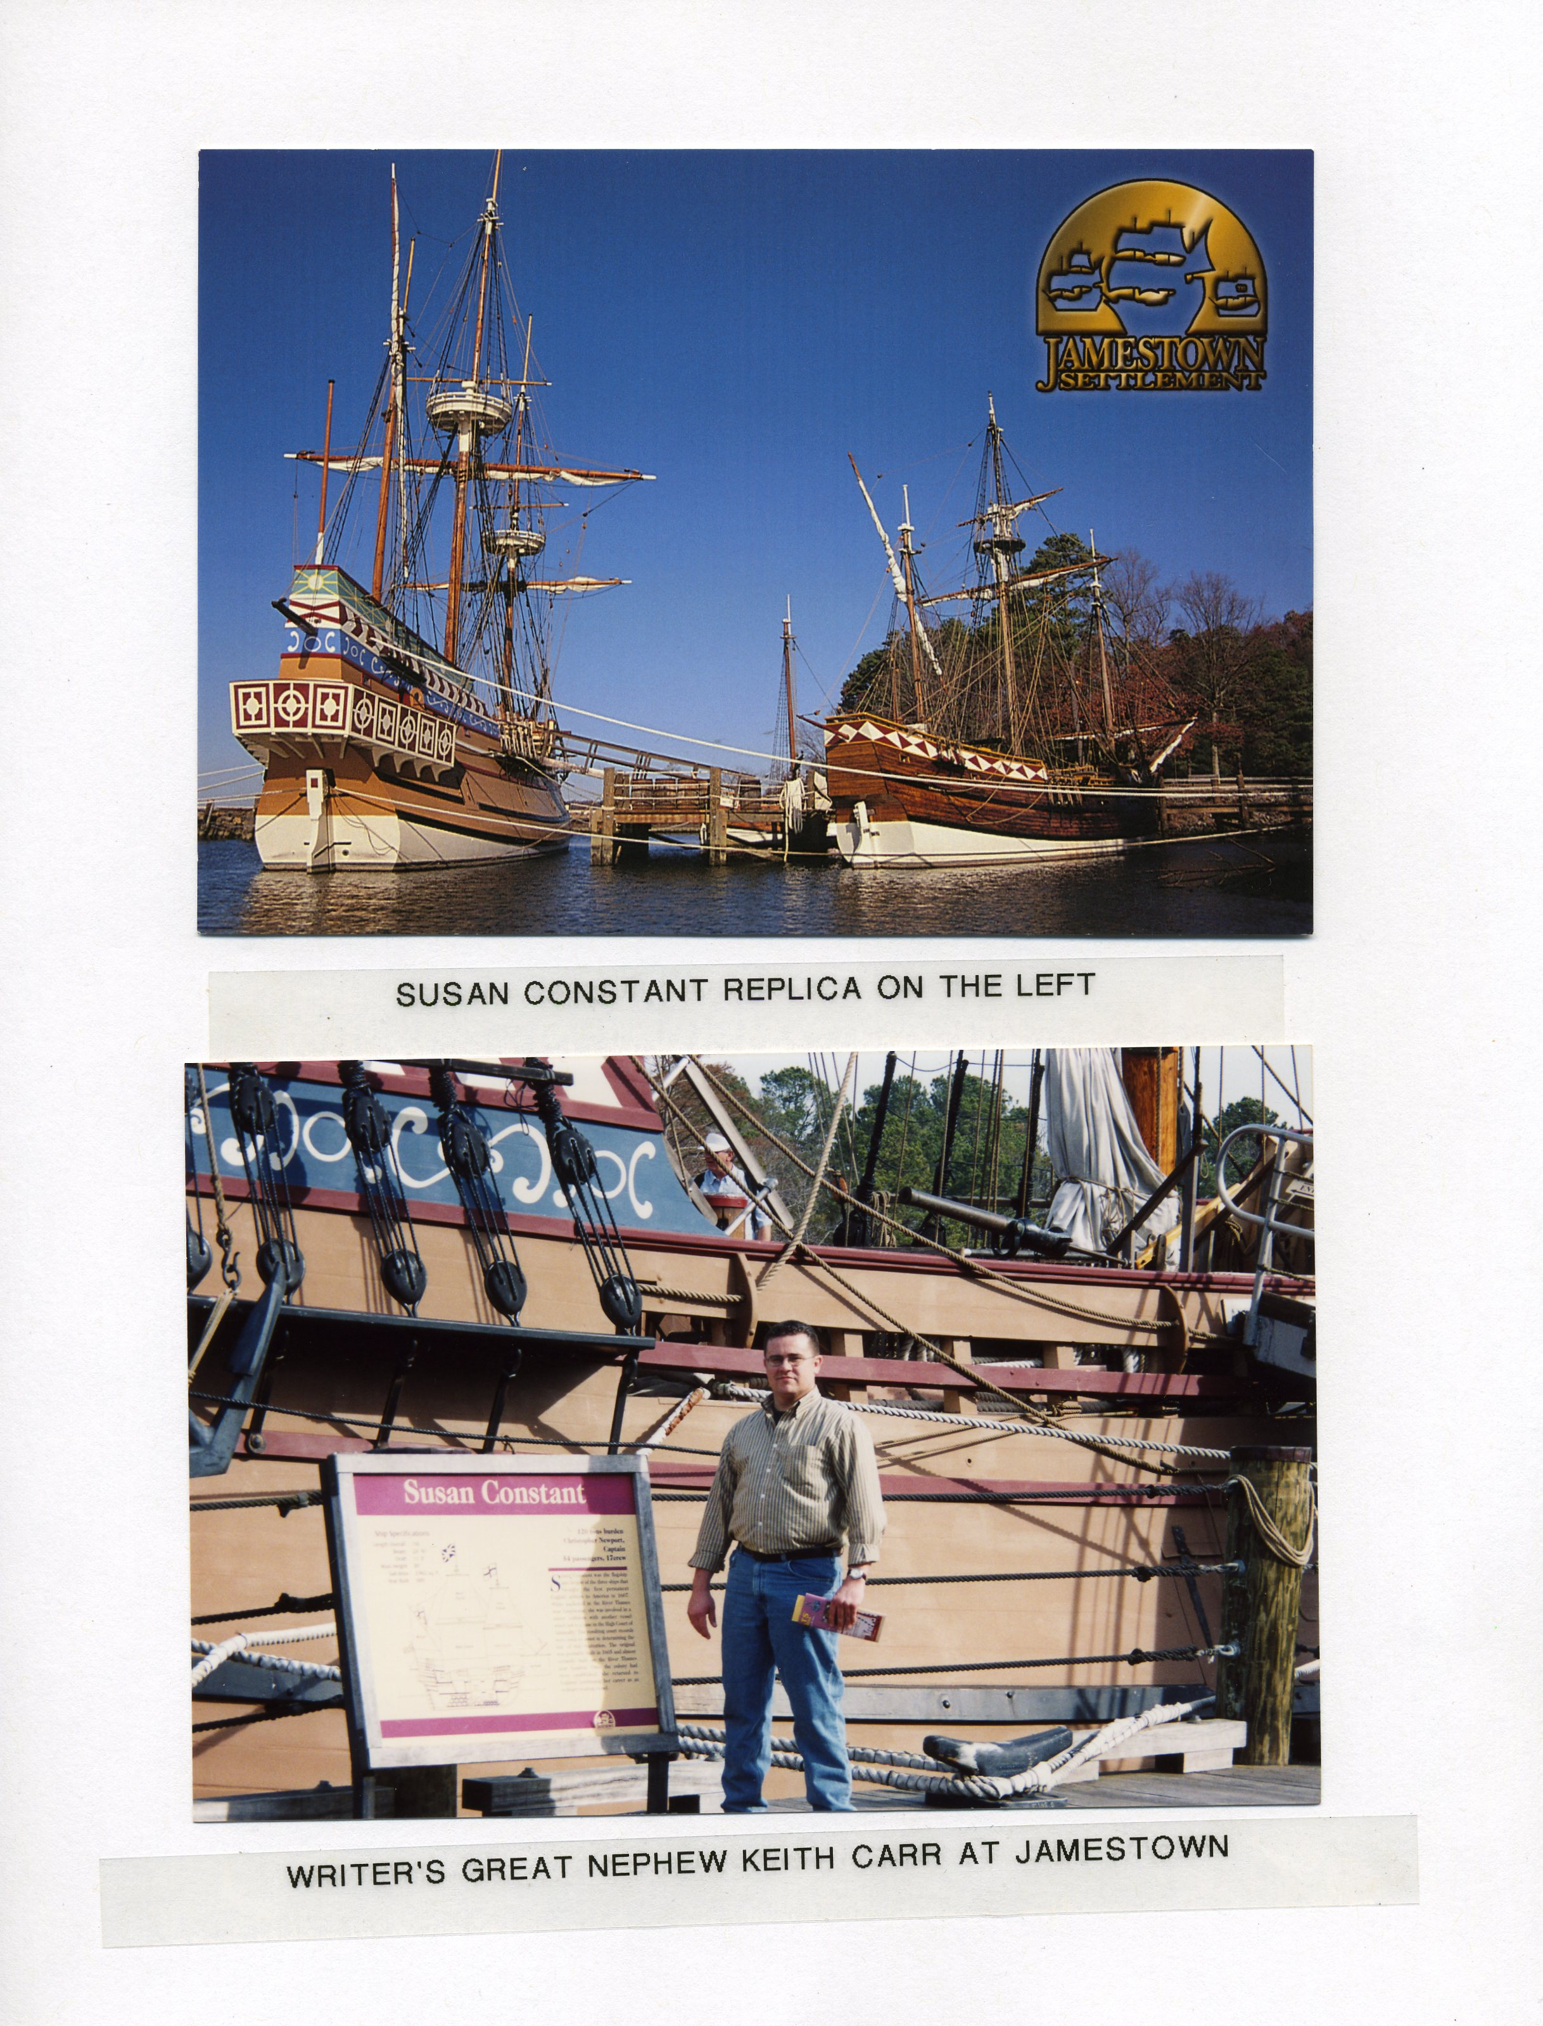

Boddie, Mrs. John Bennett, Historic Southern Families, Volume XVI, Baltimore, MD: Genealogical Publishing Company, 1971, pages 147-149.
Outlaw, Abner Henry, Outlaw Genealogy, Second Edition, Greensboro, North Carolina: Private Printing, 1972, page 15.
Archives of Maryland, Proceedings of the Provincial Court 1666-1670. Volume 57, Page 239. .
Ibid, page 306.
Nugent, Nell Marion, Cavaliers and Pioneers, Abstracts of Virginia Land Patents and Grants, Volume 2 (1666-1695), Richmond: Virginia State Library, 1977, pages 234-235.
Seaman, Holly S., MANITOBA, Landmarks of Red Letter Days, 1610-1920, Winnipeg, Manitoba, Canada, 1920, page 13.
Davies, K. G., Henry Kelsey, Dictionary of Canadian Biography Online, University of Toronto, Canada.
Crouse, Nellis M., Lemoyne D’Iberville, Soldier of New France, Baton Rouge: Louisiana State University Press, 2001.
Hudson’s Bay Records Society, IX (Rich); XI, XX (Rich and Johnson); XXI (Rich). Coll. de manuscrits relatifs à la Nouv.-France, II, 222. P-G. Roy, Inv. concessions, IV, 135. Chevalier de Troyes, Journal (Caron). Tanguay, Dictionnaire, I, 456. Webster, Acadia, 106.
Stephen, Scott P., Masters and Servants: The Hudson’s Bay Company and Its Personnel, 1668-1782, HBC (London) to George Geyer & Council, (Port Nelson), 22 May 1690, L. O. 1688-1696, 99-100.
Parker, David W., Guide to the Materials for United States History in Canadian Archives, Washington D.C.: Carnegie Institution, 1913, page 220.
Archives of Maryland, Proceedings of the Council of Mayland, 1696/7-98, pages 216-217.
The Library of Virginia, Virginia Colonial Records Database, Reel Number 782, Connor, Ludovic – lawsuit involving – SR 05486, p. 1-5.
Champlain Society, The Publications of the Champlain Society, Canada: The Society, 1949, Volume 9, page xi.
Laut, Agnes C., The Conquest of the Great Northwest, Being the story of the Adventurers of England known as the The Hudson’s Bay Company, Volume 1, New York: The Outing Publishing Company, 1908, pages 193-194.
Publications of the Prince Society, Established May 25th 1858, Radisson’s Voyages, Boston: John Wilson and Son, 1885, page 323.
Willson, Beckles, The Great Company, New York: Dodd, Mead & Company, 1900, page 118.
Le Jeane, Jonis Marie, Dictionnaire general de biographie, histoire literature, agriculture, ... Universite d’Ottowa, 1931, Page 494..

