dl32_1 (1x1000) rpm
dl32_2 (g) (side)
dl32_3 (mph)
dl32_4 (PSIg)
dl32_5 (g) (accel)

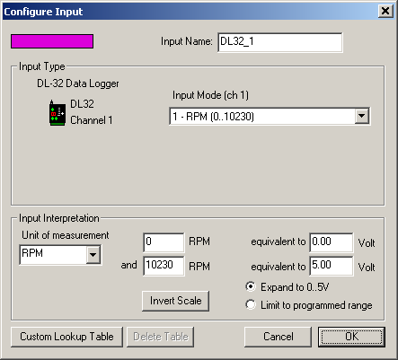

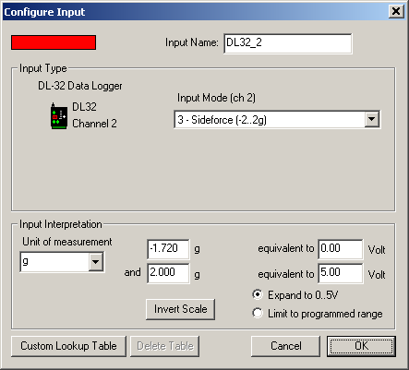

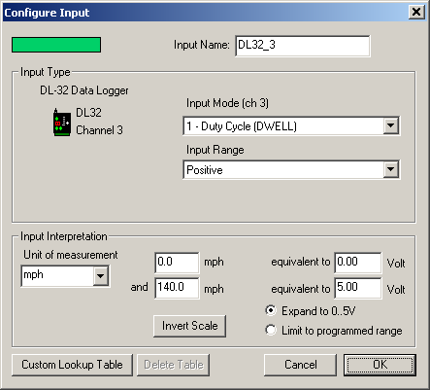

signal input is from Digital Speed Sensor, 5 volts - 24 pulses per revolution
Harness 29I red/white wire
(not ecu pin 29 5 volts - two pulses per revolution)
The range to 140 mph seems to be accurate. I don’t think the voltage ever gets to 5 volts .

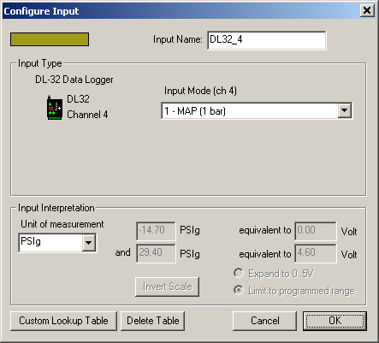

PSI is from Autometer 4777 Boost gauge
PSIg Volt
-14.7 0.000
10.0 2.000
15.0 2.410
29.4 4.600

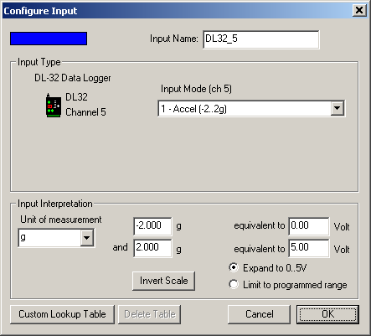

HP-z31:

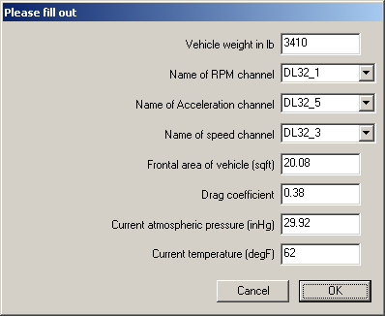

?Vehicle weight in lb = m[3410]
?i Name of RPM channel = rpm [DL32_1]
?i Name of Acceleration channel (g) = ACCEL {g}[DL32_5]
?i Name of speed channel (mph) = mph{mph}[DL32_3]
?Frontal area of vehicle (sqft) = Ar[20.08]
?Drag coefficient = Cd[0.38]
?Current atmospheric pressure (inHg) = atmp[29.92]
?Current temperature (degF) = temp[62]

v = mph * 1.4672645086030913

#SAE correction factor
SAEcf = (1.18 * ((29.235/atmp) * sqrt((temp + 459.67)/536.67)) )- 0.18

#air density
density = 0.0412236 * atmp/ (temp + 459.67)

# tire radius in ft
#R = td/24

# aerodynamic draq in lbforce
Fa = 0.5 * density * (v^2) * Ar * Cd

F = m * ACCEL + Fa
powr =v * F * SAEcf/550
MC(RWHP;hp;0) = powr
# torque from this:
MC(RWtorque;lbft;0) = powr * 5252/rpm

Torque-z31:
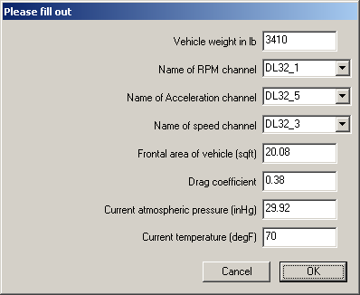

?Vehicle weight in lb = m[3410]
?i Name of RPM channel = rpm [DL32_1]
?i Name of Acceleration channel = ACCEL {g}[DL32_5]
?i Name of speed channel = mph{mph}[DL32_3]
?Frontal area of vehicle (sqft) = Ar[20.08]
?Drag coefficient = Cd[0.38]
?Current atmospheric pressure (inHg) = atmp[29.92]
?Current temperature (degF) = temp[70]

# convert MPH to Ft/Sec (mult by magic number):
v = mph * 1.4672645086030913

#SAE correction factor
SAEcf = (1.18 * ((29.235/atmp) * sqrt((temp + 459.67)/536.67)) )- 0.18

#air density
density = 0.0412236 * atmp/ (temp + 459.67)

# tire radius in ft
#R = td/24

# aerodynamic draq in lbforce
Fa = 0.5 * density * (v^2) * Ar * Cd

F = m * ACCEL + Fa
powr =v * F * SAEcf/550
MC(RWtorque;lbft;0) = powr * 5252/rpm

